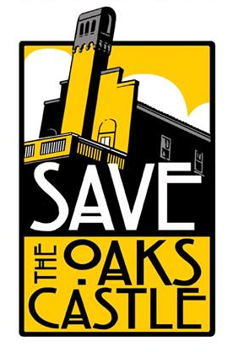
The Oaks Castle
Digital Communications

There are two main ways you can get involved with Save the Oaks Castle online. We have an online chat forum on Slack (S) and an announcements e-mail mailing list (M).

Just leave your contact information, and we'll add you to the appropriate services.

If you have any additional questions, feel free to direct them to info@oakscastle.org.
The Oaks Castle Digital Communications Sign-Up

Name | E-Mail | S | M
Jane Artist | jane@oakscastle.org | ✔ | ✔
Name | E-Mail | S | M
Jane Artist | jane@oakscastle.org | ✔ | ✔
Name | E-Mail | S | M
Jane Artist | jane@oakscastle.org | ✔ | ✔
Name | E-Mail | S | M
Jane Artist | jane@oakscastle.org | ✔ | ✔
Name | E-Mail | S | M
Jane Artist | jane@oakscastle.org | ✔ | ✔
Name | E-Mail | S | M
Jane Artist | jane@oakscastle.org | ✔ | ✔

